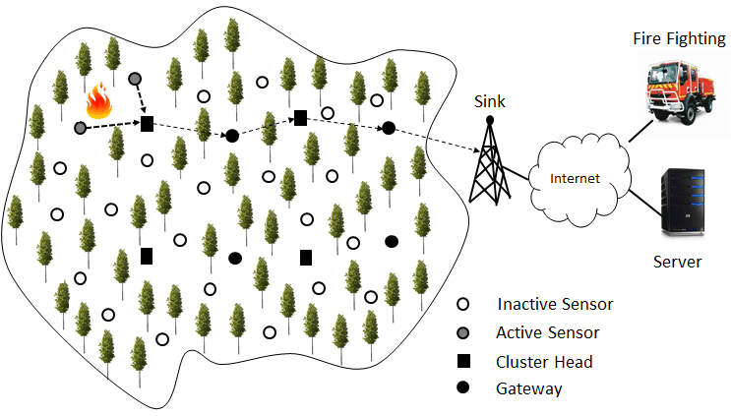 CAMERA A.I

FIRE

 DETECTED

FOREST FIRE NO FIRE

ALERT

By

Team Id:PNT2022TMID06939

Sivanesh

Sathish

Sethuraman

Siva sankar